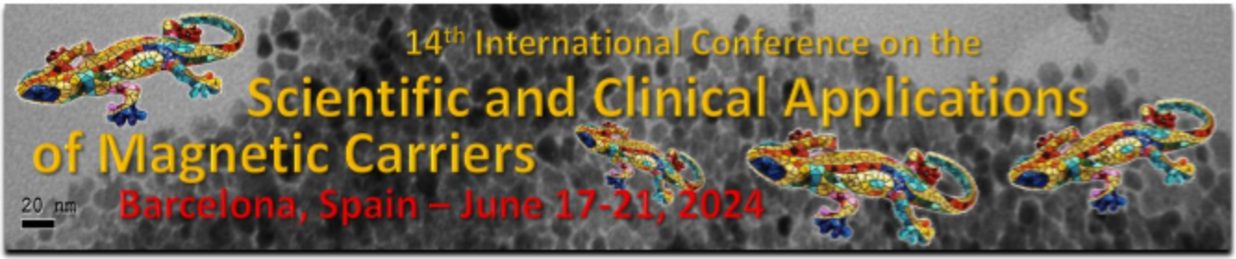

April 25, 2023

FIRST NAME LAST NAME
YOUR INSTITUTION
YOUR ADDRESS
YOUR CITY WITH ZIP CODE
COUNTRY

Invitation to the 2024 Magnetic Carrier Conference in Barcelona, Spain

Dear Mr/Ms/Prof/Dr LAST NAME:
It is a pleasure to invite you, Mr/Ms FIRST NAME LAST NAME, to our 14th International Conference on the Scientific and Clinical Applications of Magnetic Carriers. Our meeting will take place from June 17-21, 2024 in Barcelona, Spain. We are looking forward to have you report your newest research in the field of magnetic carriers with us!
If you need more information, please visit our website at www.magneticmicrosphere.com or e-mail me directly at urs.hafeli@ubc.ca.

With best wishes,

Prof. Urs Hafeli
Chairman, 14th International Conference on the
Scientific and Clinical Applications of Magnetic Carriers
Tel +1 604 822 7133

