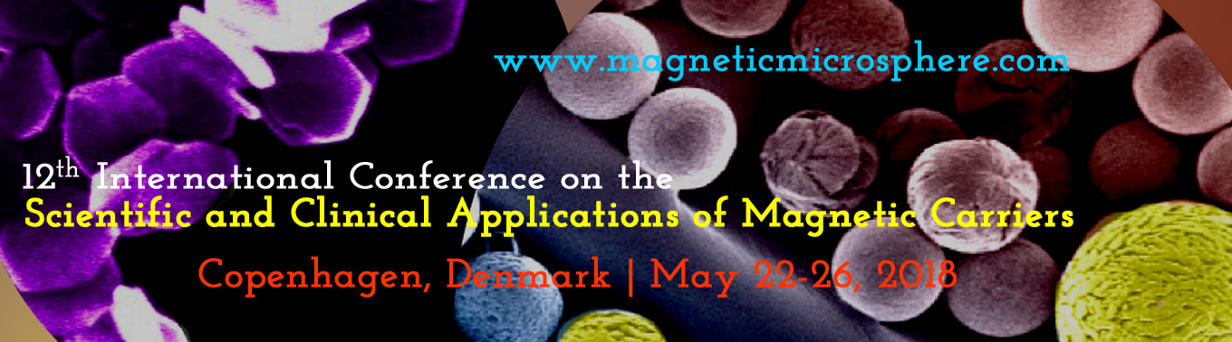

August 27, 2017

FIRST NAME LAST NAME
YOUR INSTITUTION
YOUR ADDRESS
YOUR CITY WITH ZIP CODE
COUNTRY

Invitation to the 2018 Magnetic Carrier Conference in Copenhagen, Denmark

Dear Mr/Ms/Prof/Dr LAST NAME:
It is a pleasure to invite you, Mr/Ms FIRST NAME LAST NAME, to our 12th International Conference on the Scientific and Clinical Applications of Magnetic Carriers. Our meeting will take place from May 22 - 26, 2018 in Copenhagen, Denmark. We are looking forward to have you report your newest research in the field of magnetic carriers with us!
If you need more information, please visit our website at www.magneticmicrosphere.com or e-mail me directly at urs.hafeli@sund.ku.dk.

With best wishes,

Prof. Urs Hafeli
Chairman, 12th International Conference on the
Scientific and Clinical Applications of Magnetic Carriers
Faculty of Health and Medical Sciences, Department of Pharmacy, University of Copenhagen, Universitetsparken 2, 2100 Copenhagen, DENMARK
Tel. +45 5010 9443

